Software Reference Architecture
SWEN 656 – Fall 2020
Debashis Jena
University of Maryland Global Campus

Table of Contents
1 Introduction 1
1.1 Overview 1
1.2 Scope 1
1.3 Key Authoritative Sources 2
2 Context 3
2.1 Guiding Principles 3
2.2 Constraints and Assumptions 3
2.2.1 Constraints 3
2.2.2 Assumptions 4
2.3 Alignment Priority Areas 5
2.3.1 Automation of the marketing efforts 5
2.3.2 Ease of use 5
2.3.3 PCI SSC compliance 5
2.3.4 Customer’s PII security 6
3 Data 7
3.1 Storage 7
3.1.1 Salesforce 7
3.1.2 AWS S3 7
3.1.3 Zuora 8
3.1.4 MySql Database (Amazon RDS) 8
3.2 Data Integrity 8
3.2.1 Physical Integrity 8
3.2.2 Logical Integrity 8
3.3 Data Archiving 9
3.3.1 Salesforce Data Archival 10
3.3.2 Webpage Assets Archival 11
3.3.3 Transactional Data Archival 11
4 Software 12
4.1 Business Logic 12
4.1.1 Top of the Funnel – Lead Generation 13
4.1.2 Middle of the funnel – Order Processing 13
4.1.3 Bottom of the funnel – Order Fulfillment 13
4.2 User Interface 14
4.2.1 Salesforce User Interface 14
4.2.2 Order Form User Interface 15
5 Technical Positions 17
5.1 Campaign Setup In Salesforce 17
5.2 Order Form – Spring MVC Framework 18
5.2.1 Model 19
5.2.2 View 19
5.2.3 Controller 20

Introduction
Bull vs Bear Research (BBR) is a financial research company. They employ the researchers who research the current stock market situations and they publish their research findings. The investors follow these publications to make decisions about their stock market investments. BBR currently has a customer base of 8 million readers.

Overview
BBR publishes these researches on their website and also they sell these as physical books. The online publications require an authenticated set of username and password combination. Whereas, the book purchase only requires a valid address. A critical part of the business has been the lead generation process and makes the sells to the targeted customers. As the customers buy the products, they are required to be fulfilled with a subscription or a book. The entire process is complicated and involves many different systems and resources. The following section will elaborate on the scope of this project in detail.

Scope
The scope of this project is to automate the order processing part, based on the offer and price choices setup and fulfill the customer with an online subscription. Currently, the marketing team has access to Salesforce where they can create a basic campaign record with one or more offer price choice records. The marketers also will create the HTML content which will be attached to the campaign. This project requires creating a webpage for this campaign which will contain the HTML and display the offer price choices. The webpage will be a static one. A billing order form will be embedded into the page, which should process the credit card payments securely. As the payment is successfully processed, a set of authorization and authentication records will be created. An order fulfillment email will be sent to the customer.

Key Authoritative Sources
This project involves many systems and components. This is a complex project ranging from mid to large in size. The ideas and concepts have been retrieved from different sources. Here is a list of all of them.
Reference | Retrieved From | Author | Year
3.2 Introduction to Spring | Course Material for SWEN 656 Advanced Software Design and Implementation | n.a. | 2019
3.4 Introduction to Hibernate | Course Material for SWEN 656 Advanced Software Design and Implementation | n.a. | 2019
The Ultimate Guide To Campaigns In Salesforce | https://garysmithpartnership.com/salesforce-campaign-members/#:~:text=Fundamentals%20of%20Salesforce%20Campaigns,prospects%20that%20received%20marketing%20activity. | Gary Smith | 2020
Amazon S3 Storage Classes | https://aws.amazon.com/s3/storage-classes/ | n.a. | 2020
Spring MVC: A Tutorial, Second Edition | http://library.books24x7.com.ezproxy.umgc.edu/toc.aspx?bookid=112787 | Deck, Paul | 2016
Java Persistence with Hibernate, Second Edition. | http://library.books24x7.com.ezproxy.umgc.edu/toc.aspx?bookid=147163 | Bauer, C. Gavin, K., and Gary, G | 2016
Payment Card Industry Data Security Standard | https://en.wikipedia.org/wiki/Payment_Card_Industry_Data_Security_Standard | n.a. | n.d.

Context

Guiding Principles
The principles are defined as high-level statements that are strictly applied to the business domain. In this case, the business domain can be classified into two categories based on the customers; the marketing setup and the order creation. The principles are more or less the same for both types.
- Systems availability – The applications must be available to the respective users all the time. In the case of the marketers, they should be able to access Salesforce and setup campaigns 100% of the time. Similarly, the order processing must go on smoothly, even without any supervision.
- Prompt fulfillment – Upon successful payment, the customer must be fulfilled immediately.
- Users’ information safety – Any information related to the users must be kept secured.
- Higher valued implementations – Business requirements are taken higher precedence than any programming enhancements or technical debt or refactoring.
- Priority requirements – Any part of the SRS that deals with revenue shall be a higher priority.

Constraints and Assumptions

Constraints
Constraints in a software development project are defined as the restrictions that dictate the actions of the development team. Here are a few constraints that apply to this project.
- The interest of the steering committee – The executive team and the project sponsors need to have an interest in the project development and progress. If there is a lack of interest, then the project lead may struggle to get the support or resolution of problems.
- Cost – With the utilization of cloud-based technology, a lot of infrastructure-related tasks will be moved to the cloud companies, removing the need for on-premise server purchases and removing the need for employing a network administrator. However, it may incur the expenses for having your infrastructure remotely. Having a hard limit on the budget may affect project implementation.
- Manpower and Skills – This project requires developers and analysts from different backgrounds. The project has the usage of Salesforce, Amazon Web Services (AWS), and advanced Java. This constraint has bad impacts on the project start dates, which may lead to project delivery delays.
- Availability of stakeholders – While this is an important project, that is going to automate the setting up the marketing engine, stakeholders also have their current responsibilities. So making time to be available for this project may be hard for them, but their availability is essential and critical.

Assumptions
Typical IT projects are subject to many changes. Even after the product is delivered, the change requests are raised and are also accommodated. Usually, no one has answers to all the project-related questions in the beginning phase of the project. So some of the assumptions are needed to be taken to get the project started. Here is a list of the assumptions taken for this project.
- Resources – Three main resources are required for any IT project to be successful; such as people, materials, and funds. For this project, skillful developers and analysts are required. It is assumed that the project implementation team has the necessary tools, infrastructure, and environment to deliver it.
- Technology – Java, being a widely-used programming language, it is assumed that there will be no issues with regards to technology.
- Time-based – This is a mid to large-size project. It requires its own time to get it released on time.
- Quality/specification assumptions – It is expected that the business analysts or the product owners will work with the end-users to get a well-documented specification, that can be referred while coding for the application.

Alignment Priority Areas
BBR is a small size company, however with the stock market fluctuations in recent times, it has been growing exponentially by the number of customers and the revenue. It has been difficult for the company to fulfill the customer's demand for the products. This project is to automate the overhead tasks that the marketing team has been performing. Here are a few priority areas that need to be addressed as part of the project delivery.

Automation of the marketing efforts
The main objective of this project is to automate certain marketing efforts that the marketing team is performing manually. Usually, the editors will come up with content along with the contact information and payment method section. This content then is added to a new webpage and then the link is sent to the prospective customer emails. This contains many manual activities. The top priority of this project delivery is to automate the webpage creation along with injecting a standard order form containing a common HTML section to capture the contact information of the customer and the credit card details.

Ease of use
One of the objectives of any automation project is to make the product extremely easy to use. In this project, the product will make the marketers use the basic functionalities of Salesforce, which is self-explanatory and highly intuitive. The users will not have to go back and forth between applications to set up a marketing campaign. They should be using the only application which is Salesforce to create the campaigns and offer price choices.

PCI SSC compliance
Since the application deals with many credit cards and financial details of the customer, it is highly imperative that the credit card information is safe and is not exposed to the public anyway. So PCI SSC (Payment Card Industry Security Standards Council) has developed and continues to revise the Payment Card Industry Data Security Standards (PCI-DSS). These standards need to be followed to be a compliant service provider, failing to which will cause being banned from using the cards from these companies. The top two bullets from these standards enforce you to do the "Build and Maintain a Secure Network and Systems” and “Protect Cardholder Data”. This project should ensure the network and systems are secure enough to protect the card holder’s data and card information.

Customer’s PII security
PII stands for Personally Identifiable Information, which includes the email, address, and phone number of a person. As the users enter the personal information on the order form page, their information must be secured end-to-end. There are many ways to make this information secure. However one of them is simply encrypting the data with a key that is accessible only to the decrypting systems.

Data
As the application captures and saves several key information about the campaign and the orders, the data can be classified into different categories based on their sources and databases.
- The first part of this project is the campaign setup, which requires a table to save the campaign, offer price choices, and other related static metadata.
- Then the HTML and other static resources like the CSS files and inline JavaScripts.
- Thirdly, all the billing related items; such as invoices, payments, and subscription records.
- Authorization and authentication data.

Storage
As the data is different so are the data sources. Here we will describe the data sources in detail.

Salesforce
For the campaign setup, it requires basic metadata records. Salesforce provides the inbuilt feature to set up a campaign and the related records. Since the marketers are assumed to possess the skills to work with Salesforce standard pages, it can be selected as the source for the campaign information. Also, the campaign analytics data can be saved in Salesforce too, which may include the number of total visits, the total number of orders, net and gross revenue generated from a campaign or an offer.

AWS S3
Amazon Web Services (AWS) has one of their cloud services which is called Simple Storage Service (S3) that provides object storage through a web service interface and using their REST APIs as well. An object can be any kind of file like an HTML page, JS or CSS file, and even JSON files. AWS can expose the files on a webpage with very high performance and minimum response time. So these HTML files can be treated as local files.

Zuora
Zuora is another cloud service that provides a subscription-based billing system and can communicate with many payment gateways like PayPal, American Express, Vantiv, and Braintree. It saves the billing accounts, payment methods, subscriptions, invoices, and payment records in its databases which can be queried via their REST and SOAP APIs securely.

MySql Database (Amazon RDS)
For saving the subscription authorization and authentication records, a MySql database will be selected and it can be hosted within Amazon’s Relation Database Service (RDS). MySql provides relational database management capability and user-friendly query language.

Data Integrity
From the data integrity perspective, both physical and logical data integrity will be taken care of.

Physical Integrity
Physical integrity is defined as the protection of the data accuracy and wholeness as it is stored and retrieved. In the case of a natural disaster or a power outage, the physical integrity may be affected. Therefore the cloud services were selected, which will ensure there is always a backup service that comes into effect in case of an outage. Also, some of the cloud services within AWS and Salesforce are securely backed up to a fraction of seconds. Therefore the data loss does not happen and physical integrity is not impacted by any external events.

Logical Integrity
As the logical data integrity is concerned, it is the responsibility of the development team to ensure the data validations are in place. The correct relationship between the data entities is maintained accurately.

Entity Integrity
Each of the data sources has some or other types of entity integrities already inbuilt. For the campaign to relate metadata, a unique key is defined to save for the product type. Similarly, in the MySql database, the customer id and the subscription id are defined as the primary key which prevents any duplication of the records. These keys are also defined as “not null”, making sure the data does not have a null value as a primary key.

Referential Integrity
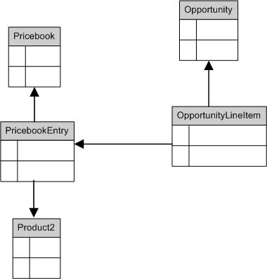
Salesforce has the relationship between the data entities or objects established as look-up or master-detail ones. This automatically creates the primary key and foreign key reference points. The master-detail relationship does not let you create a child record without a master record. That takes care of the referential integrity between critical objects. In this example, the price book entries are looking up to the price book entity, meaning Pricebook and PricebookEntry share a parent-child relationship. Similarly, the data entities function within Zuora as well. They have a tightly coupled relationship between the billing accounts, payment methods, and subscriptions.
Referential integrity within the authorization and authentication tables are created with basic primary key and foreign key definitions within the tables.

User-defined Integrity
Some of the user-defined validations can be added within Salesforce which prevents the user from inserting an invalid record or an inadmissible situation within the data system. For example, an offer price choice must have a one-time charge along with a recurring charge and the recurring charge must always be less than the one-time charge. This can be added as a validation rule within the Salesforce object which will stop the insertion of a record which does not satisfy the above condition. Similarly, the MySql database can have indexes which can make sure the records are unique from one of the attribute perspective or combinations of multiple.

Data Archiving
Typically, after a while, some of the data becomes mostly redundant. However, as a part of the system, no data can be deleted. However, the redundant or infrequently accessed data will be archived in a database or in a location that is low cost and low maintenance. Since the data is assumed to be looked up for rarely or less often than the other transactional data, it should be stored in an inexpensive location, with a moderate data retrieval response time.

Salesforce Data Archival
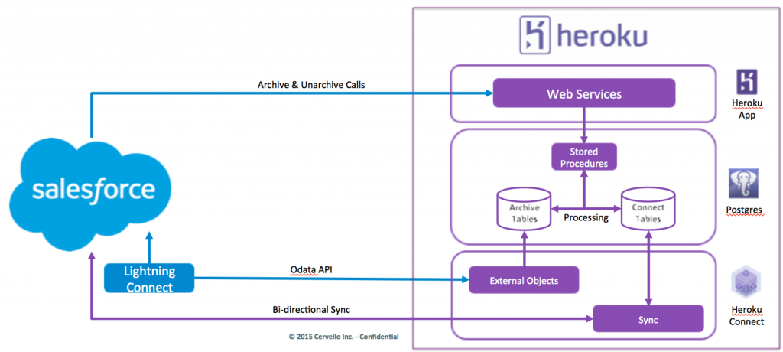
A campaign has an expiry date when the offer is shut off meaning the users cannot place an order for the campaign. The related stats of the campaign; such as the order form visits, clicks, sell made, the total number of orders, and the revenue, are saved in the salesforce database. The campaign-related data of these expired campaigns become redundant. Salesforce data storage is typically expensive. So archiving these redundant data saves some money towards the Salesforce data storage. There are many third-party services available, which can be purchased at a low cost. These third-party services will archive these data safely and securely with a way to retrieve the data on-demand. Typically these third-party services save the data in an external data source and Salesforce can orchestrate these data within the application just like any other internal entities. In the following example, Heroku Connect has been used as a data archival system. Heroku maintains a live connection with Salesforce all the time. As the data entities are selected and the data mappings are done, the data is synced to Heroku. It saves the data internally in a Postgres database and gives an option to add the data as an external data source within Salesforce.

Webpage Assets Archival
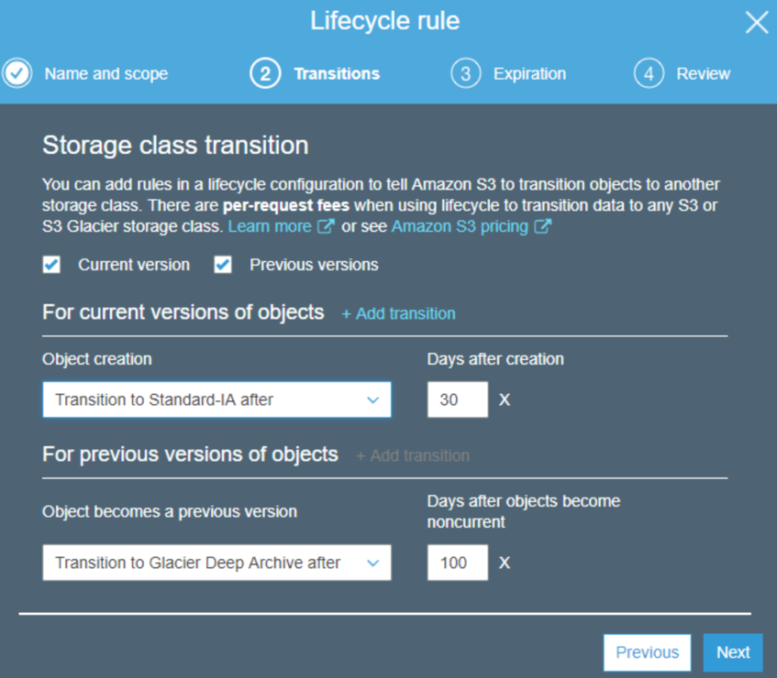
Just like the campaign data, some of the HTML page sources, related CSS and JavaScript files are not reusable. Therefore, they can be archived within AWS. S3 is a service that has many classes based on their availability and retrieval time. They vary by the cost of usage. AWS recommends a data archival policy. These policies can be easily set at the S3 file level as “Lifecycle Rules”. As the following picture shows, an object can be transitioned to an IA (Infrequently Accessed) class S3 bucket after 30 days of creation. AWS automatically moves these files based on the rule definition. Similarly, after 100 days of the object push, it is archived in Amazon Glacier, which is a data archival system within AWS.

Transactional Data Archival
For all the transactional data, the MySql database is used. However, when the data becomes old and not accessed often, this data can be pushed to a database that can be easily retrieved. As these data are no more accessed to do any new transactions, they can be moved to a columnar database. AWS provides many columnar databases like RedShift which is typically used for analytics. Otherwise, the data can be moved as a JSON file to an S3 location periodically, where the data lifecycle rules can be applied to completely move the data to Glacier. Many ETL tools can be used to automate this process. AWS also offers its inbuilt DMS application that can be used for this purpose.

Software
The basic software in this project will be web-based and will comprise many different components. Each of the components has different end-users. One of the components is the marketing campaign setup within Salesforce, which will be used by the marketers within the company. Then the order form will be used by potential customers. The billing system will be managed by the admins and lastly, the customers will consume the auth part of the system.

Business Logic
The BBR mainly runs a B2C (Business-to-Customer) type model, where they target the personal investors. Typically they publish the stock market news along with a detailed research report on a particular area based on the researcher’s field of expertise. They sell these publications online. Some of the publications are free and can be availed via the website or by subscribing to the e-letters. The following figure describes the business flow in a funnel view.
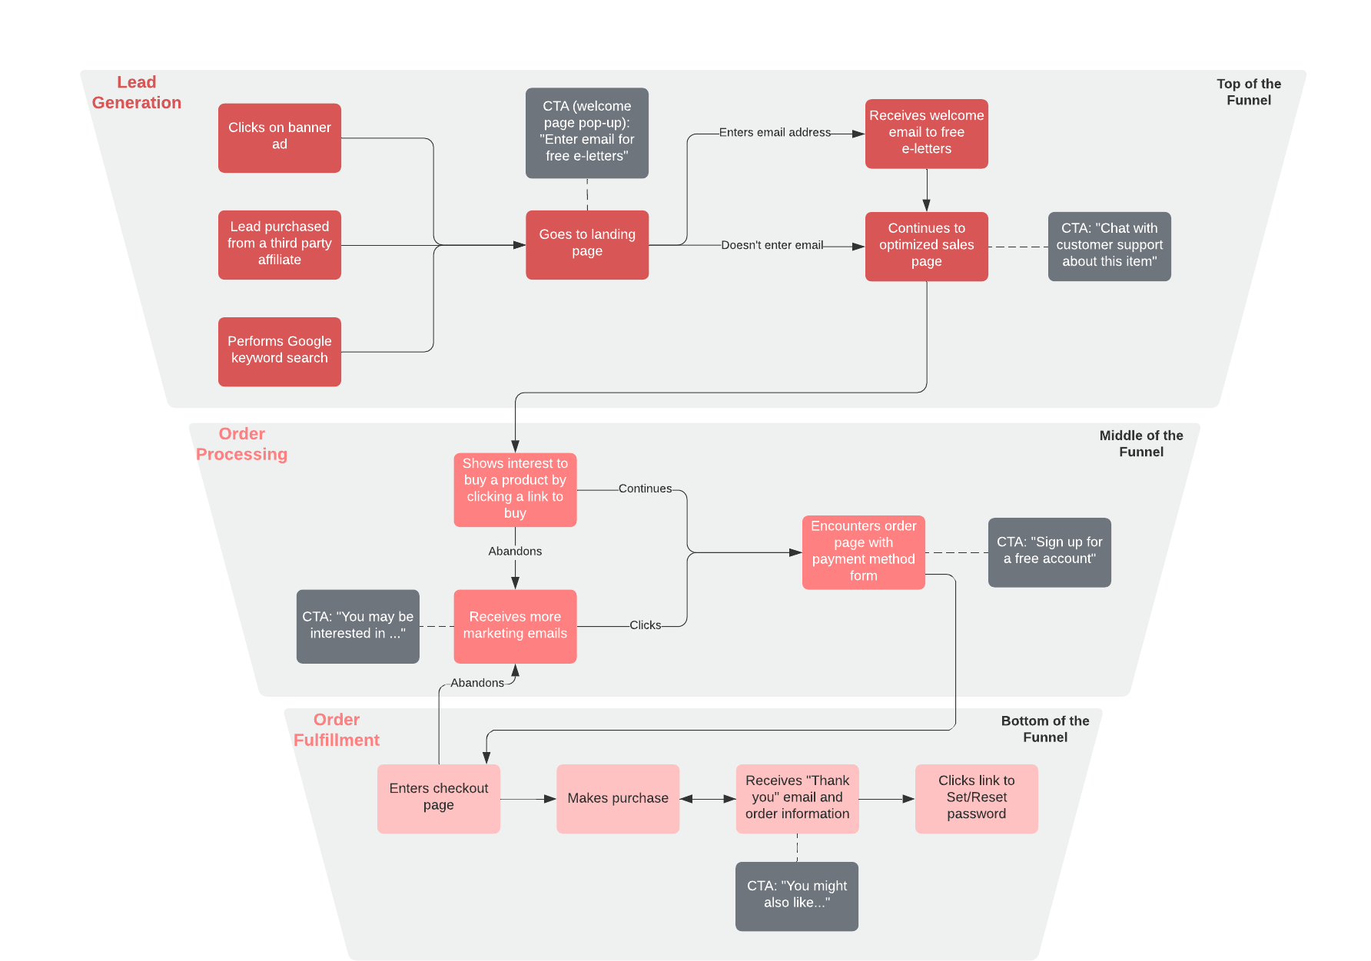

Top of the Funnel – Lead Generation
The first and foremost part of the sales process is lead generation. A lead is defined as a potential customer who may be interested in the commodity or service that the seller is selling. In this case, the researchers looking for more advice on the stock market investment are the leads. The space ads and Google sponsored ads or banners are displayed on the browser. As the customer clicks the ads, they are shown a pop-up window with an email field to be entered so that the customer is subscribed for the exclusive free e-letters. As the website captures the email address, the customer is added to the company’s database as a potential customer. Apart from this, the leads can be purchased in bulk from a third party affiliate. This information typically has an email address and/or a phone number. A sale can be done via a phone call or by sending marketing emails.
The lead generation part is not in scope for this project.

Middle of the funnel – Order Processing
As the lead email addresses are captured, they are sent with marketing emails with exclusive offers, which is typically a discounted price for a product of interest. When the customer clicks the link, s/he lands on a page that may contain more information about the product and an order form. This order form will have a part to capture the payment method details of the customer. As the order request is submitted the processing part starts. Additionally, there may be more upsell or cross-sell pages after the order is processed. However, the application should not ask for the payment method information anymore but asks for consent from the user to use the same payment method that was used for the main sell.

Bottom of the funnel – Order Fulfillment
When the order processing is complete, the user receives an order confirmation email with a 'Thank you' note. This email will contain more information on how to use the subscription effectively. More importantly, the email will have a link to set up the online account. As the email address was entered during the order processing, the same will be used as the username. The customer will only be asked to set/reset the password.
Now the order fulfillment is complete. Users may process to login to the website to view and access the subscription purchased. Each subscription has an expiry date as well. Unless it is renewed, the subscription access will be removed.

User Interface
The user interfaces vary from each other by the applications. In the current application, we only have to deal with the user interface within Salesforce and the new user interface that will be created for the order form that the customer sees. The following sections will elaborate on each of the user interfaces with examples.

Salesforce User Interface
As Salesforce provides its user interface with some standard pages to create new records and it's associated child records. In our case, we will take the most advantage of the inbuilt campaign object and we will create an offer price choice entity that will have a master-detail relationship with the campaign. Since most of the standard functionality of Salesforce will be used in this project we will not have to create any custom pages or use any custom code.

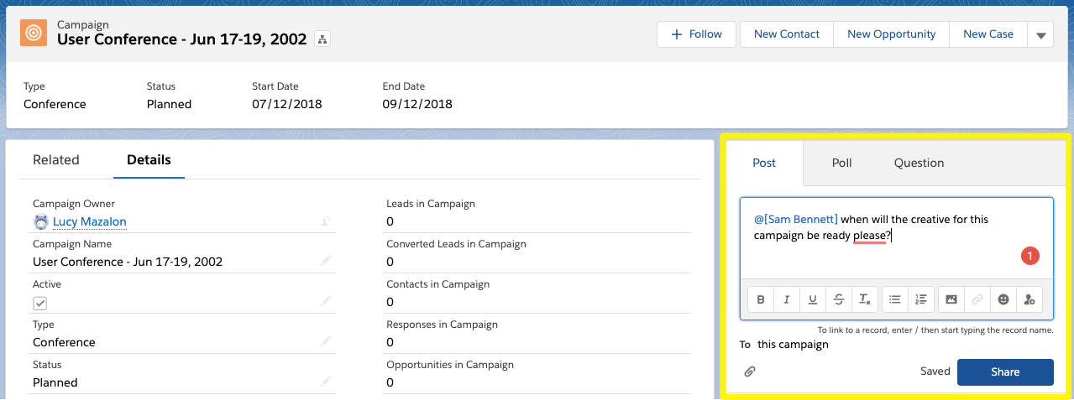
Figure 4.2-1 Salesforce Campaign Page

Here is a sample standard page in Salesforce for the campaign entity. When the offered price choice entity is set up and the records are creator they will display under the related tab and above page. The offer creation page will look very similar to this campaign page since both are the standard record creation pages. As mentioned above most of the declarative programming will be utilized which will be easy to implement and will require low maintenance. As the project scope expands and additional changes are requested, custom code implementations will be done as required.

Order Form User Interface
The order form is expected to look simple. The application will not contain any complex logic like the cart or check out pages. The order form page will be a static HTML page with some additional CSS and JavaScripts. No complicated navigation is required for the order form. However, it must have a form to capture the contact information and the payment method details.
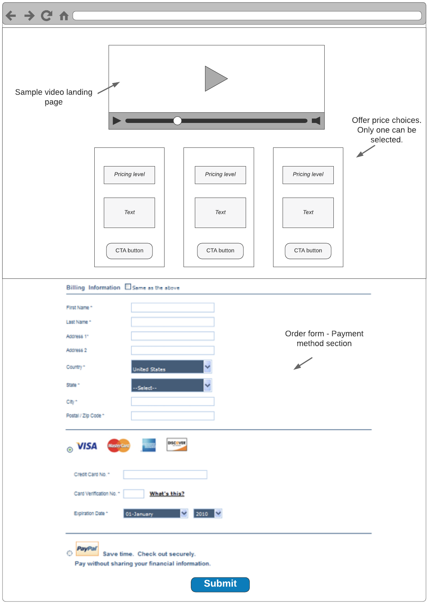
Figure 4.2-2 - Sample Order Form
The above figure is for a sample order form page. The details of the page are elaborated below by each of the sections.
- The top section should contain the static HTML page created by marketers, it may be a video landing page as well.
- The next section is an optional one. If there are multiple offer price choices offered by the campaign, then the price choices will be displayed with a radio button at the top. One of the options must be selected by default.
- The contact information and payment method section is a standard frame, which should be the same for all the campaigns. It basically should capture the name, email, phone number, and address of the customer. In the next section, it should request the payment method that needs to be used for the order.
- Finally, the Submit button should display at the bottom of the order form. The button should create a subscription in the system.
- Optionally, the marketers may set up upsell/cross-sell / down-sell pages. As the order is processed, the system should take the user to the next pages as per the configuration.
- The payment method information should only be asked once; i.e. only during the main sell. In other orders, the flow should be straight forward and should be driven by simple button clicks.

Technical Positions
The application in scope has many components. Each of the components will have its implementation following the respective framework. The first part is the campaign and price choices set up in Salesforce, then the order form generation with the information from the Salesforce configuration, and finally the auth creation for the customer. The below sections will elaborate on the details of each.

Campaign Setup In Salesforce
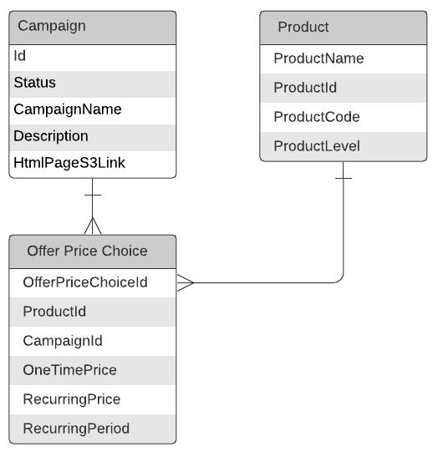
Salesforce has some of the standard entities which they otherwise call standard objects. The campaign is one of the standard objects, which has many inbuilt features like setting up campaign hierarchy. The current project will take utilize the standard objects as much as possible. However, to have the ability to create multiple offer price choices for a campaign, we'll have to create another custom object. Salesforce provides a self-explanatory user interface to create any custom object. Salesforce creates some of the standard fields for all custom objects; such as the primary key id which is an auto-generated number, created date, created by, etc. The indexes for some of these fields are also created in the background. For additional indexes, the Salesforce support can be contacted, who can help in this regard.
Figure 5.1-1 Salesforce schema setup
- The entity-relationship diagram shows that the campaign is the parent object. This campaign object also has a column to save the HTML asset link saved in AWS S3.
- Product is another standard object that can be utilized to set up the product catalog.
- Offer price choice is the custom object which becomes a direct child of the campaign. It has an independent look up to the product table.

Order Form – Spring MVC Framework
This is the most critical part of the project. The idea is to query Salesforce for the campaign data along with the HTML link. The HTML content saved in the S3 link will be the first part of the order form page (As shown in Figure 5.2-1). As the second part, the standard payment method section will be injected with a Submit button. For this Spring MVC framework will be followed.
MVC stands for model-view-controller. This is one of the spring design patterns which uses Java as the programming language. MVC framework is a request-driven, designed around the dispatcher servlet which sends the requests to controllers by mapping the paths mentioned as part of the request.
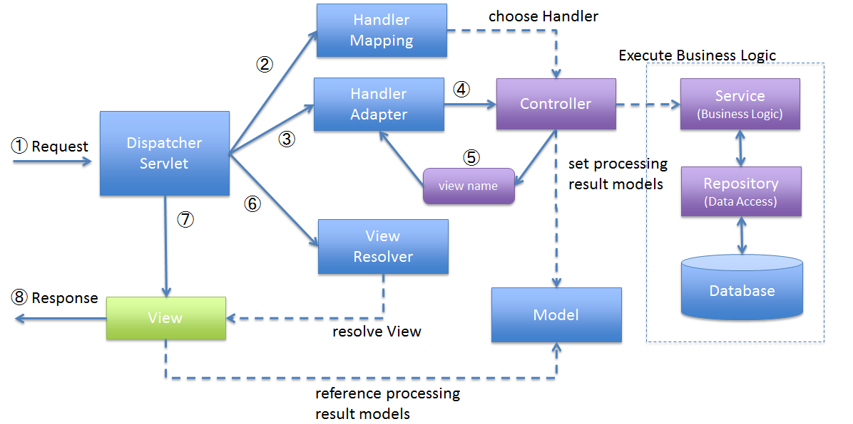
Figure 5.2-2 MVC architecture
In figure Figure 5.2-2 - MVC architecture, the blue boxes are provided by the Spring framework itself and do not have to be designed by the developers. The purple boxes above are the ones that need to be programmed by the developers. The green view part is a mix of both since the basic view is provided by Spring but needs to be implemented by the developers.
In this project, the concept of Spring MVC will be utilized. The breakdown of the system has been elaborated as follows.

Model
The main model in this project is within Salesforce. The campaign, product, and offer price choices will be queried using the REST APIs provided by Salesforce. SOQL is the query language used in the Salesforce world to get the record details from any object. The request from the view will contain the basic information about the campaign which is the record id. Using the record id, the campaign details will be queried. As part of the campaign record response, the HTML content URL will be captured.
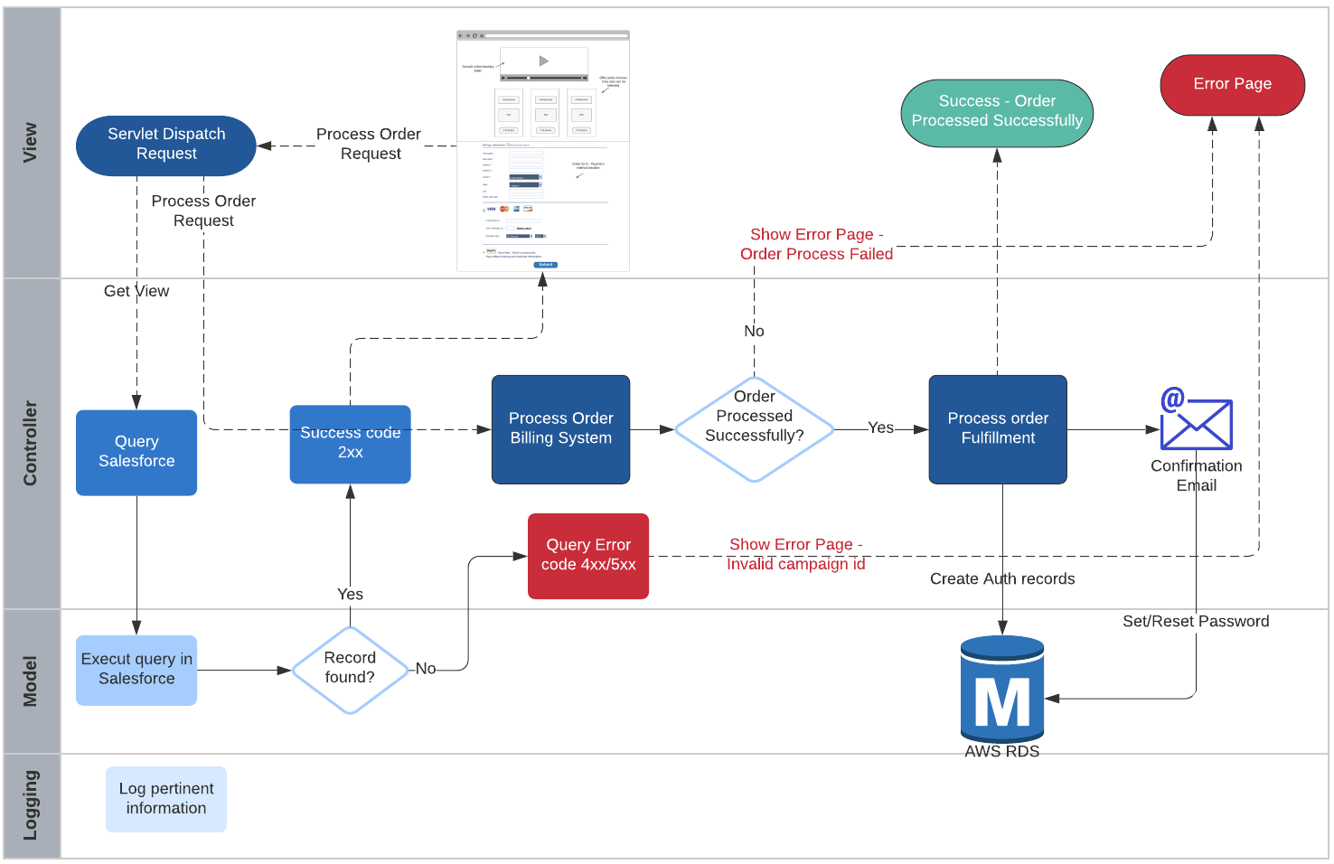
Figure 5.2-3 Order Processing Spring MVC

View
As part of the order form, the view is retrieved by querying the site details from Salesforce. A separate API will be developed to query the data from Salesforce with the campaign id as the key. The campaign id will be passed as part of the query string in the URL. As shown in figure 5.2-3, the servlet will dispatch the request to the site details API. If the campaign id passed is an invalid one, then the user will be displayed an error page. With a valid campaign Id, the system should display the full order form page with the HTML content and the payment method fields.

Controller
When the user enters the details and selects the Submit button, another call should be made to the controller with a request to process the order. Now the controller gathers all the data and tries to process the payment in the billing system. In case of an order processing failure, like a bad credit card or invalid selections, the application should display an error page saying "The order processing failed. Contact customer service.".
In case of a successful order, the system should asynchronously make a call to create the authorization/authentication records, send a confirmation email, and display an "Order successful." Message.

Hibernate for Creating Auth Records
Upon a successful order processing, the user needs to be fulfilled with online subscription access. The access can be achieved by having an authentication record created with a username/password. The next step will be authorization, which should come into play if the user is first authenticated. The authorization would simply be a record in the authorization table, with the information about the product that was purchased.
To have the controller communicate with the database and perform the required transactions, an ORM tool should be used. ORM or Object-Relational Mapping is simple a framework, that provides the capability to map an object-oriented model to a relational database model. Using Hibernate, the tables can be mapped to Java classes. Similarly, the table columns can be mapped to the class variables. While mapping the data types, it should be ensured that they match the MySql datatypes.
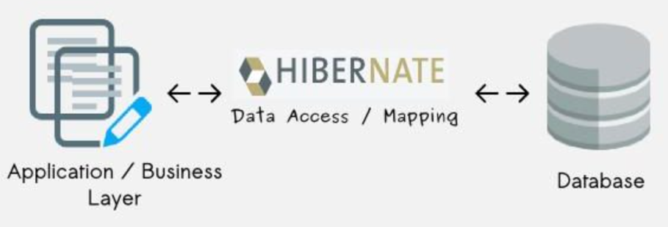
Using the standard annotations and methods, the data will be extracted and required CRUD actions will be performed.

